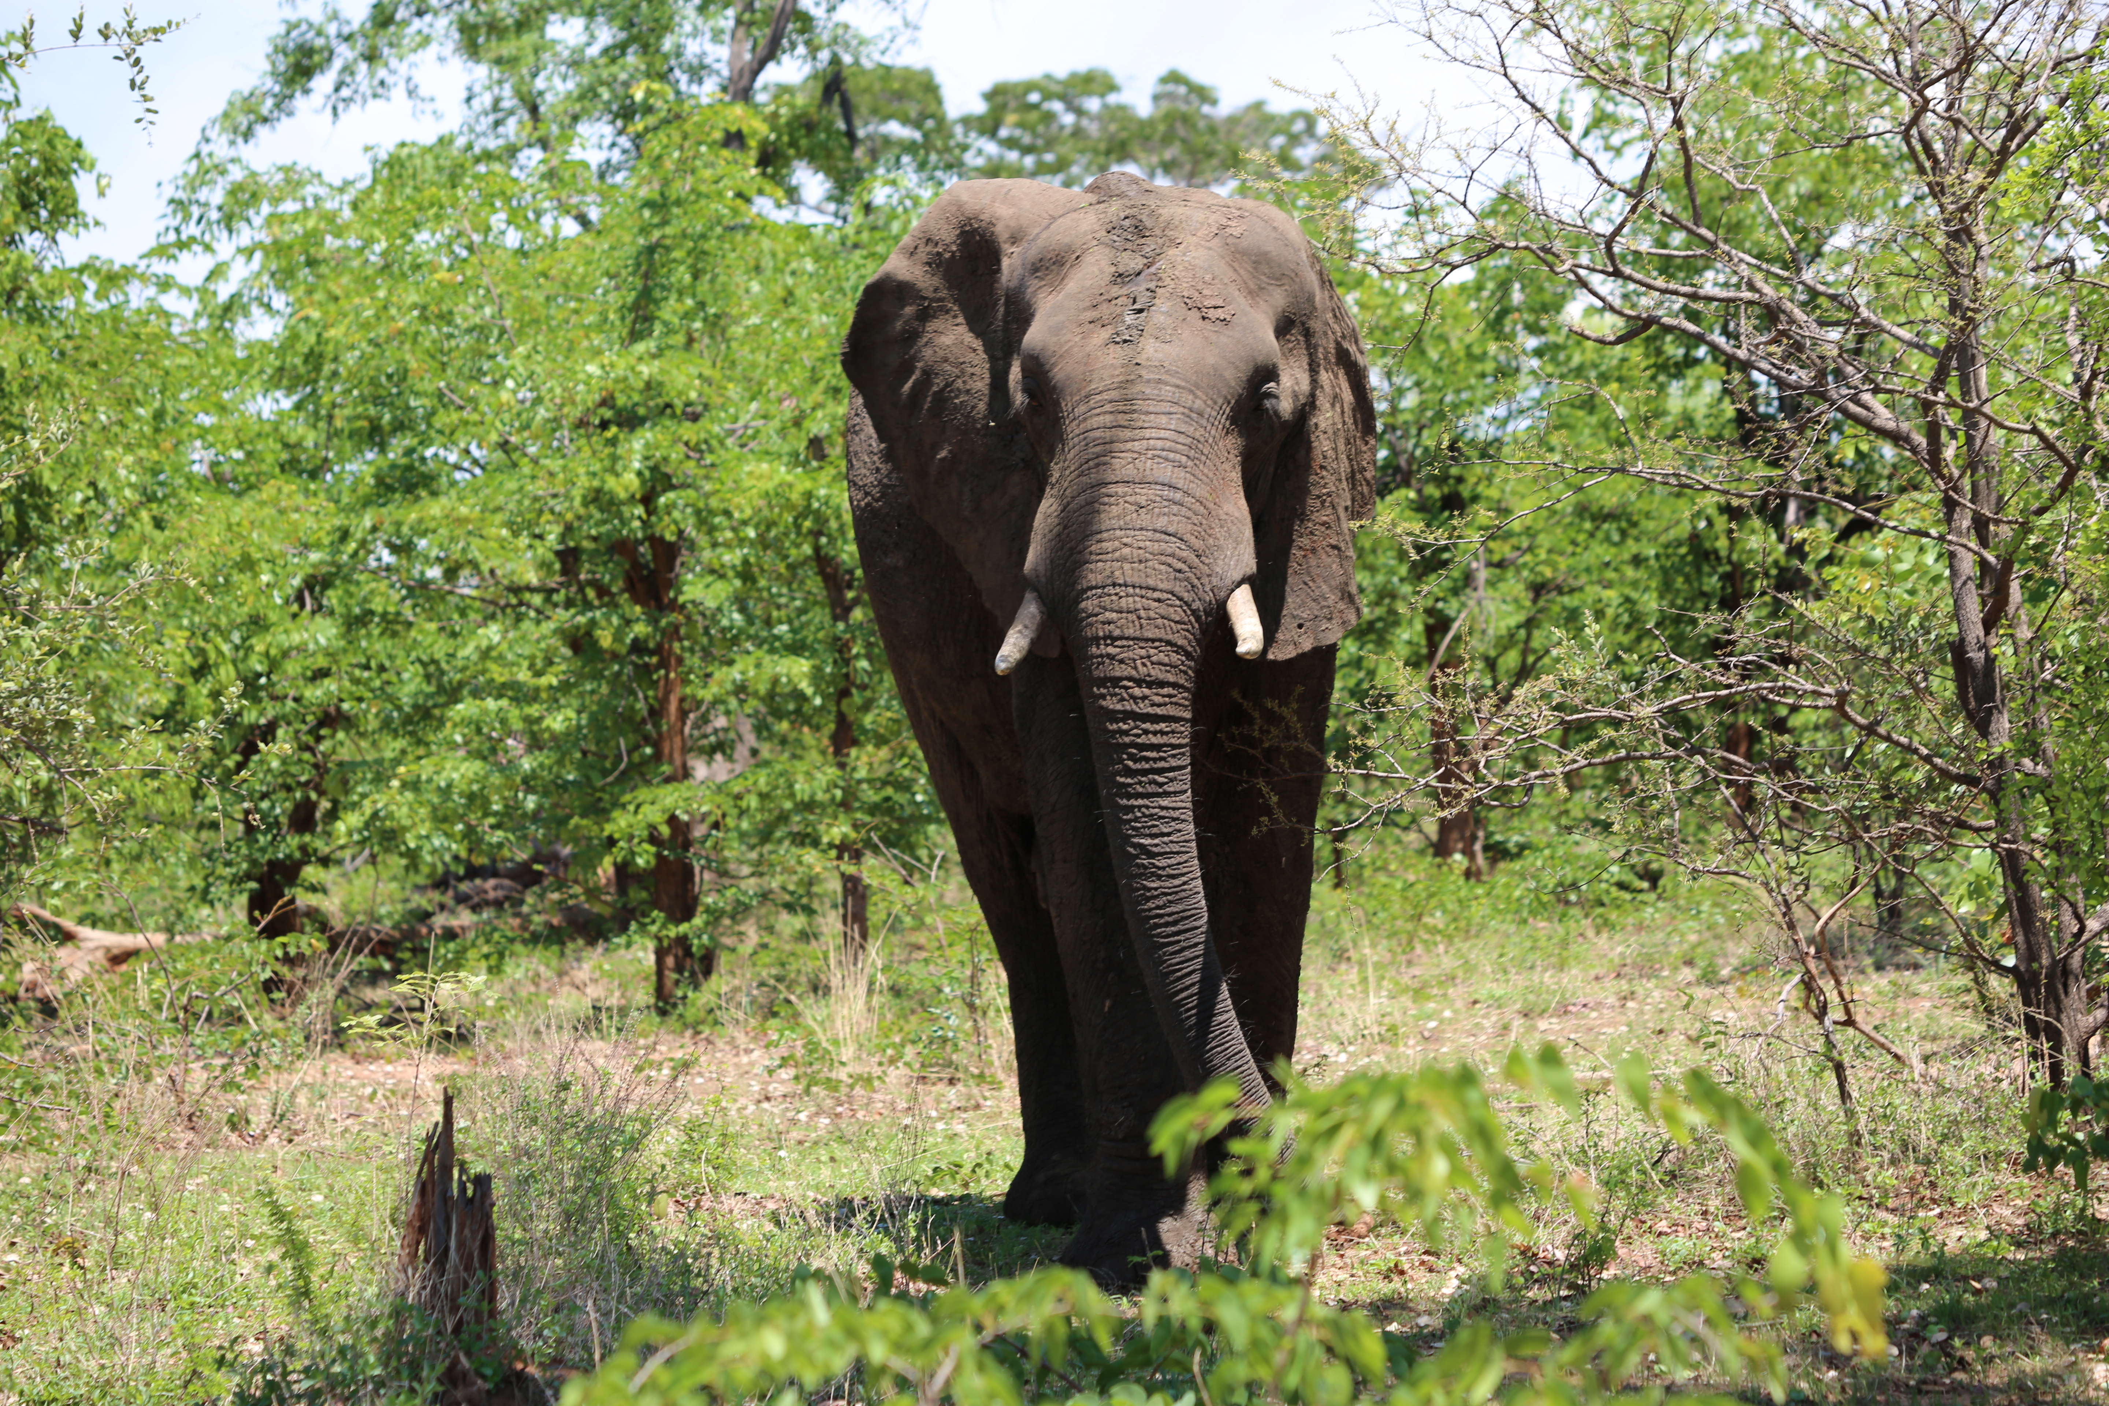

address
134 Cathedral Road, Pontcanna, Cardiff
CF11 9JB

name
Robert Zyborski

DOB

30/08/82

WEBSITE
www.televisioncameraman.wales
www.droneoperator.wales

Phone
07474 253945

email
rob.zyborski@gmail.com

Work History

R o b e r t Z y b o r s k i CURRICULUM VITAE

Films, tv series, photography, film making, art film installations, art galleries, music, running, gym, fishing, walking, wildlife, fresh air, mountains, wine, eating out, cooking, travel, culture

Aberystwyth University

2004-2007
BA (Hons) Film & Television
(2:1)

extra-curricular
English, Welsh and Spanish:
Fluent
French: Basic

Languages
MA Filmmaking
(Distinction)

Bangor University 2012-2013

Education
October 2018 – present, Freelance Drone Pilot for television series incuding Gwesty Aduniad and Hen Blant Bach (Darlun / S4C) , The Village and Return to the Mountain (Slam / ITV)
March 2014 – present, Freelance Camera Operator / PSC for Companies including Slam Media, Cardiff (PSC Camera operator on several projects including ITV's The Strait & The Harbour, ITV Wales' Welsh Horse Power & The Mountain, and S4C's Chwys & Rasus); Antena, Caernarfon. (PSC & Studio Camera operator for items on Y Lle and Ochr 1 ranging from factual TV to music videos); Rondo, Caernarfon (PSC & Studio Camera operator on factual programmes including Clwb, Sgorio & Pwy Di Bos Y Gegin) and Orchard, Cardiff (Camera operator for various corporate projects and TV docs).
October 2013 - November 2015. Zoom Cymru, The Factory, Jenkin St, Porth. Filmmaking mentor for various community filmmaking projects with school children and youth groups in both north and south Wales.
July 2012 – September 2012. Objective Productions, Westminster Bridge Rd, London. Location assistant for E4’s Tool Academy.
January 2010 – July 2012. Bonitaworld Media Productions, Barcelona & Frame Zero, Barcelona. Freelance camera assistant on shoots ranging from corporate video to music videos and adverts.
July 2008 – Dec 2009. Tinopolis, Park St, Llanelli. Full time camera operator for live studio and SNG broadcast television. I worked daily on the live broadcast of Wedi 3 and Wedi 7.
September – December 2007 & 2008. Boomerang, 218 Penarth Road, Cardiff. Camera assistant, 2 Dy a Ni.
December 2007 – January 2008. Subotica Entertainment, Dublin. Camera trainee , The Daisy Chain, Super 16mm

